ECONOMICS

2010-

2018

[SCHOOLINGS](schoolings.org) JAMB

Questions And

Answers

# UTME 2010 ECONOMICS QUESTIONS

1. Which Economics question paper type is given to you?
   1. Type A
   2. Type B
   3. Type C
   4. Type D
2. Economics is the study of human behaviour as it relates to the
   1. efficient allocation of resources
   2. production of goods
   3. operation of companies
   4. generation of income
3. The downturn in the prices of shares on stock markets is a highlight of
   1. efficient allocation of resources
   2. the invisible hand
   3. the regulatory nature of the market
   4. consumer rationality
4. If = 6 and N = 6, determine the value of

∑fx

* 1. 36
  2. 12
  3. 1
  4. 72

1. The standard deviation of a set of data is
   1. always measured from the mode
   2. the most representative of averages
   3. always measured from the median
   4. a measure of dispersion
2. The mean is the best measure of central tendency because it
   1. is not affected by extreme values in a data
   2. is a midpoint value in an array of data
   3. is a balancing point in an observation
   4. can be calculated from incomplete data
3. The most popular sizes of dresses and shoes are determined by the
   1. range
   2. mean
   3. mode
   4. median
4. If the demand for a good is more elastic than its supply, the tax burden is borne
   1. equally by consumers and producers
   2. more by producers
   3. more by consumers
   4. more by retailers and producers
5. If the price of a commodity with elastic demand increases, the revenue accruing to the producer will
   1. double
   2. increase
   3. be constant
   4. decrease
6. An excess demand for beans will result from
   1. an increase in the price of beans
   2. a decrease in the price of beans
   3. an increase in the supply of beans
   4. a decrease in the supply of beans
7. Consumer surplus tends to be higher when demand is
   1. inelastic
   2. perfectly elastic
   3. elastic
   4. unitarily elastic
8. One of the assumptions of ordinal utility theory is that
   1. choice is not consistent
   2. utility can be ranked
   3. total utility is a function of price
   4. satisfaction is measurable
9. The law of diminishing marginal utility explains why
   1. the slope of a normal demand curve is negative
   2. an abnormal demand curve slopes upwards
   3. the slope of a normal demand curve is positive
   4. the consumption of inferior goods increases with income
10. If a consumer plans to spend 120k on four oranges but spent 80k, his consumer surplus is
    1. ₦1.50
    2. ₦0.40
    3. ₦1.00
    4. ₦2.00
11. A set of factors that can shift the supply curve are changes in
    1. weather, price and technology
    2. technology, weather and population
    3. technology, price and taste
    4. population, price and taste
12. If the coefficient of price elasticity of supply is greater than one, the supply is said to be
    1. perfectly elastic
    2. fairly inelastic
    3. infinitely inelastic
    4. fairly elastic
13. If commodity X is a by-product of commodity Y, this implies that both commodities are
    1. in competitive supply
    2. in composite supply
    3. jointly supplied
    4. in excess supply
14. In perfect competition, price is determined by the
    1. government
    2. sellers
    3. buyers
    4. market
15. In order to reduce hardship faced by consumers due to high prices government can introduce
    1. maximum prices
    2. commodity boards
    3. minimum prices
    4. price control boards
16. Average product is less than marginal product when
    1. there is constant returns to scale
    2. there is increasing returns to scale
    3. there is decreasing returns to scale
    4. diminishing returns set in
17. A firm enjoying economies of scale is said to be
    1. reducing average cost as production increases
    2. benefiting from the activities of other firms
    3. maximizing profits as production increases
    4. having an upward-sloping average cost curve
18. The rising portion of the long-run average cost curve of a firm is an indication that it is experiencing
    1. increasing efficiency
    2. economies of scale
    3. diseconomies of scale
    4. increasing marginal returns
19. An industry's supply curve is more likely to be elastic when firms are
    1. enjoying free entry and exit
    2. operating at full capacity
    3. operating below capacity
    4. maximizing profits
20. One of the characteristics of monopolistic competition is that
    1. there is mobility of factors of production
    2. no single seller dominates the market
    3. the firms are price-takers
    4. consumers have perfect knowledge of price
21. The demand curve for factors of production
    1. is perfect elastic
    2. slopes upwards
    3. slopes of downwards
    4. is perfectly inelastic
22. An agreement among firms on price and segmentation is termed
    1. cartel
    2. collusion
    3. haggling
    4. specialization
23. In national income accounting, tax is determined by the
    1. level of income
    2. level of consumption
    3. level of investment

` D. rate of savings

1. A decrease in aggregate spending in an economy will ultimately lead to
   1. boom
   2. inflation
   3. deflation
   4. recession
2. If MPC is 0.7 while government expenditure increased by ₦ 150m, the equilibrium national income is
   1. ₦ 214 million
   2. ₦ 45 million
   3. ₦ 105 million
   4. ₦ 500 million
3. The function of money which makes division of labour possible is its
   1. unit of account
   2. store of value
   3. medium of exchange
   4. standard of deferred payment
4. By buying treasury bills, the Central Bank of Nigeria intends to
   1. increase money supply in the economy
   2. reduce the cash reserve ratio for banks
   3. reduce money supply in the economy
   4. increase the capital base of commercial banks
5. The velocity of money is represented as
   1. Money supply

Real GDP

* 1. Real GDP Money supply
  2. Nominal GDP Money supply
  3. Real GDP Nominal GDP

1. One of the functions of commercial banks is
   1. maintaining stable price in the economy
   2. regulating monetary policies
   3. granting loans to customers
   4. issuing bank notes and coins
2. A strategy for curbing unemployment is to
   1. implement government stabilization policy
   2. increase taxes and decrease government expenditure
   3. increase government expenditure and decrease taxes
   4. ensure even distribution of job opportunities
3. In Nigeria, the distribution of job opportunities
   1. balanced budgeting
   2. deficit budgeting
   3. surplus budgeting
   4. zero budgeting
4. National development plans in Nigeria fail mainly because of
   1. overdependence on foreign aids
   2. inadequate funding of projects
   3. poor implementation strategies
   4. shortage of skilled manpower
5. The ultimate aim of agricultural policies in Nigeria is to achieve
   1. food sufficiency
   2. industrialization
   3. full employment
   4. industrial capacity utilization
6. Government can boost agricultural output in Nigeria primarily by
   1. embarking on buffer stock programmes
   2. placing embargo on food importation
   3. granting subsidies on farm inputs
   4. placing farmers on monthly income
7. Localization of industries refers to the
   1. spread of firms producing different products
   2. siting of industries near the market
   3. concentration of firms of an industry
   4. siting of firms producing different products
8. In developing countries, governments influence the location of industries in order to
   1. spread development
   2. redistribute wealth
   3. encourage entrepreneurs
   4. encourage industries to earn high profits
9. A disadvantage of Nigeria's dependence on imported petroleum products is the
   1. instability in the demand for the products
   2. dominance of multinational firms
   3. instability in the supply of the product
   4. poor maintenance of the refineries
10. The maximum number of shareholders for a limited liability company's is
    1. twenty
    2. five
    3. seven
    4. infinite
11. The primary motive for an individual engaging in production is to
    1. make profit
    2. satisfy basic human wants
    3. redistribute wealth
    4. put inputs into use

## Use the table below to answer question 44 and 45.

|  |  |  |
| --- | --- | --- |
| Year | Population | Working |
| (000) | Population(000) |
| 2000 | 25 | 13 |
| 2001 | 30 | 19 |
| 2002 | 40 | 32 |
| 2003 | 50 | 49 |

1. What is the population growth rate in 2003?
   1. 33.3%
   2. 20.0%
   3. 11.0%
   4. 50%
2. The percentage of working population in 2002 is?
   1. 50%
   2. 25%
   3. 8%
   4. 80%
3. One of the characteristics of free trade zone is
   1. common tariff against non- member countries
   2. different trade policies of non- member countries
   3. free factor mobility within the zone
   4. harmonized trade among member countries
4. If Nigeria imports vehicles from Japan the transaction will appear as a
   1. debit on Japan's balance of payments
   2. credit on Japan's balance of payments
   3. credit on Nigeria's balance of trade
   4. credit on Nigeria's balance of payment
5. One of the objectives of ADB is to
   1. provide subsidies on imported goods to member countries
   2. mobilize short-term loans for member countries
   3. promote economic and social development of member countries
   4. provide technical assistance to only poor member countries
6. The choice of the method of production in an economy is determined by the
   1. level of technical know-how
   2. rate of population growth
   3. availability of natural resources
   4. level of income
7. The amount of labour hired depends on the
   1. number of skilled labour available
   2. skill of labour
   3. marginal productivity of labour
   4. price of the inputs

|  |  |  |
| --- | --- | --- |
|  | **25.** | B |
| **ANSWER KEYS:** | **26.** | A |
| **1.** C | **27.** | A |
| **2.** A | **28.** | B |
| **3.** B | **29.** | B |
| **4.** A | **30.** | B |
| **5.** D | **31.** | B |
| **6.** B | **32.** | A |
| **7.** A | **33.** | B |
| **8.** C | **34.** | D |
| **9.** C | **35.** | C |
| **10.** A | **36.** | B |
| **11.** C | **37.** | A |
| **12.** D | **38.** | B |
| **13.** B | **39.** | D |
| **14.** C | **40.** | A |
| **15.** A | **41.** | B |
| **16.** C | **42.** | D |
| **17.** C | **43.** | C |
| **18.** D | **44.** | D |
| **19.** D | **45.** | D |
| **20.** D | **46.** | D |
| **21.** A | **47.** | C |
| **22.** A | **48.** | B |
| **23.** C | **49.** | C |
| **24.** C | **50.** | C |

# UTME 2011 ECONOMICS QUESTIONS

1. Which question paper type of economics is given to you?
   1. Type A
   2. Type B
   3. Type C
   4. Type D
2. An effective way of controlling inflation in a mixed economy is to
   1. increase productivity
   2. reduce income tax
   3. ration available output
   4. increase imports
3. One of the limitations PPC assumption is that there is
   1. no indication of technological development
   2. no recognition of preferred goods for countries
   3. technical inefficiency
   4. abundant resources
4. A major disadvantage of the arithmetic means is that it is
   1. not useful for large data
   2. not suitable for further statistical analysis
   3. cumbersome to determine the actual value
   4. affected by extreme data
5. Demand patterns are determined by the market on the basis of
   1. scale of preference
   2. consumer sovereignty
   3. consumer rationality
   4. price of the commodity
6. A consumer surplus measures the
   1. benefits derived from consuming a cheap commodity
   2. excess of total expenditure over total utility
   3. difference between marginal utility and marginal cost
   4. excess of marginal utility over price
7. If the demand for one commodity excludes another, it is said to be
   1. complementary demand
   2. competitive demand
   3. composite demand
   4. derived demand 8.

|  |  |
| --- | --- |
| Price (₦) | Quality (Kg) |
| 1 | 100 |
| 2 | 120 |
| 3 | 150 |
| 4 | 180 |
| 5 | 200 |

The graph of the schedule above will depict

1. a kinked demand curve
2. a normal demand curve
3. an abnormal demand curve
4. a diminishing marginal utility curve
5. The median of an odd-numbered set of scores is the
   1. Middle value in the set
   2. Highest value in the set
   3. Arithmetic means of the set
   4. Most frequent occurring score
6. If demand increases without a change in supply, equilibrium price and quantity will
   1. remain unchanged
   2. shift inward
   3. fall
   4. rise
7. In the process of production, total output is at maximum when
   1. MP=0
   2. MP>0
   3. AP=0
   4. AP>0 12.

|  |  |
| --- | --- |
| Price (₦) | Qty./ (bags) |
| 1 | 60 |
| 2 | 120 |

From that table above, the price elasticity of supply is

1. 4
2. 25
3. 1
4. 2
5. When a consumer is at equilibrium, the MRSxy is equal to the
   1. sum of the prices
   2. product of the two prices
   3. ratio of the two prices
   4. difference of the two prices
6. Minimum price legislation by government will
   1. reduce supply
   2. increase supply
   3. reduce demand and create surplus
   4. increase demand and create scarcity
7. Ranking is the method use in measuring
   1. marginal utility
   2. ordinal utility
   3. cardinal utility
   4. total utility
8. If a firm is faced with an elastic supply curve, its revenue will
   1. be supplied at a higher price
   2. double at a higher price
   3. increase by more than the percentage increase in price
   4. equal percentage change in price
9. The optimal range of output for a perfectly competitive firm is
   1. AC is lowest
   2. AVC is lowest
   3. MC is rising
   4. MC is falling
10. A firm will experience diseconomies of scale when
    1. there are difficulties in coordinating production
    2. there is shortage in labour supply
    3. the size of market is small
    4. there is an increase in the price of raw materials
11. The law of variable proportions is applicable only
    1. in the long-run period
    2. to large-scale enterprises
    3. to small-scale enterprises
    4. in the short-run period
12. ​

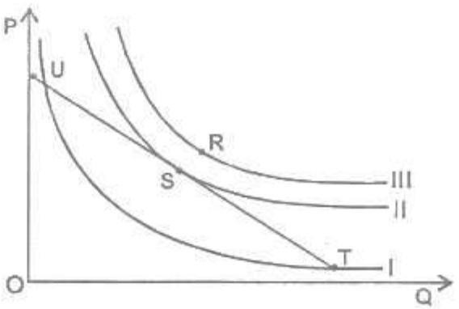

From the Diagram above, the optimal point of production is

A. R

B. T

C. U

D. S

1. If real income increases while nominal income remains the same, it can be inferred that
   1. Unemployment rate has decreased
   2. General prices have fallen
   3. Employment rate has risen
   4. General prices have risen
2. One of the characteristics of oligopoly is the availability of
   1. few sellers
   2. few buyers
   3. many sellers
   4. a single seller

## Use the diagram below to answer question 23 and 24

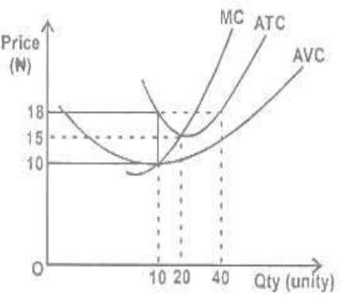

1. The average total cost when 20 units are produced is
   1. N20.00
   2. N23.00
   3. N13.00
   4. N15.00
2. When 20 units of output is produced, TC will be
   1. N360
   2. N300
   3. N460
   4. N400
3. The profit of a monopolist can be eliminated where price equals
   1. AFC
   2. MC
   3. AC
   4. AVC
4. Bank consolidation policy in Nigeria is a measure to increase
   1. the capital base of banks
   2. employment opportunities in banks
   3. the number of shareholders
   4. the number of branches
5. An increase in the circulation of money without a corresponding increase in output will lead to
   1. a rise in income levels
   2. stagflation
   3. inflation
   4. deflation
6. In national income accounts, an item counted as part of government spending is
   1. salaries and wages
   2. pension
   3. scholarship
   4. social welfare
7. If aggregate demand is lower than total output in an economy national income will
   1. be constant
   2. be at equilibrium
   3. increase
   4. fall
8. During the era of barter, money was generally in the form of
   1. notes
   2. precious metals
   3. coins
   4. commodities
9. A country achieves economic development when there is
   1. an increase in military expenditure
   2. an increase in capacity utilization
   3. a sustained increase in per capital income
   4. an even distribution of goods and services
10. An indicator of growth in an economy over a period of time is the
    1. GDP gap
    2. GDP at factor cost
    3. GDP at market price
    4. GDP deflator
11. A country embarks on deficit financing in order to
    1. increase revenue
    2. reduce aggregate demand
    3. curb inflation
    4. stimulate investment

## Use the diagram below to answer question 34 and 35

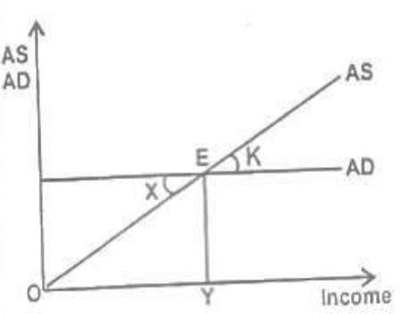

1. The deflationary gap is defined by
   1. X
   2. K
   3. X + K
   4. X - K
2. What does X represent?
   1. recessionary gap
   2. GNP gap
   3. inflationary gap
   4. deflationary gap
3. The import-substitution strategy of industrialization is to encourage
   1. domestic production
   2. large-scale production
   3. importation
   4. exportation
4. Upstream oil activities involve the
   1. management of pollution
   2. marketing of refined products
   3. exploration of crude oil
   4. refining of crude oil
5. Agricultural production in Nigeria is constrained by
   1. ineffective use of stabilization measures
   2. inadequate demand
   3. poor implementation of policies
   4. balance of payments deficits
6. The main function of NNPC is to
   1. oversee the development of the oil sector
   2. develop the oil producing area
   3. fix the price of products
   4. ensure regular supply of products
7. investing heavily in the agricultural sector will lead to
   1. sufficient food production
   2. a vibrant commodity market
   3. capital inflow
   4. stable export prices
8. Industrial development in Nigeria can be encouraged through
   1. signing WTO treaty
   2. granting subsidies
   3. the provision of efficient infrastructure
   4. direct government participation
9. The record of a country's transactions in international trade is her
   1. capital account
   2. balance of payments
   3. current account
   4. balance of trade
10. The transfer to public shareholding corporations to private enterprises is
    1. concession
    2. incorporation
    3. commercialization
    4. privatization
11. A condition in which official and autonomous exchange rate coexist is
    1. dual exchange rate system
    2. managed floating rate system
    3. market determined exchange rate system
    4. multiple exchange rate system
12. In modern economies, the Malthusian theory of population is ineffective because of
    1. birth control measures
    2. technical progress
    3. government policies
    4. natural disasters
13. Optimum population enables an economy to attain the highest level of
    1. Industrial development
    2. Income per head
    3. Revenue generation
    4. Economic development

|  |
| --- |
| 47.A change from one industry to another |
| by a worker is an example of |
| A. geographical mobility |
| B. horizontal mobility |
| C. professional advancement |
| D. vertical mobility |
| 48.The money paid per hour for work done |
| is |
| A. salary |
| B. wage rate |
| C. cost |
| D. bonus |
| 49.Trade takes place because of |
| A. marginal utility |
| B. inefficiency in production |
| C. opportunity cost |
| D. comparative advantage |
| 50.The World Trade Organization is |
| responsible for |
| A. stabilizing and harmonization oil prices |
| B. ensuring equal participation of |
| countries in trade |
| C. modernising world economies |
| D. minimizing obstacles to international |
| trade and investment |

|  |
| --- |
| **ANSWER KEYS:** |
| **1. B** |
| **2. A** |
| **3. B** |
| **4. D** |
| **5. B** |
| **6. D** |
| **7. B** |
| **8. B** |
| **9. A**  **10. B**  **11. A**  **12 C**  **13. A**  **14. C**  **15. B**  **16. C**  **17 B**  **18 C**  **19. A** |

|  |  |
| --- | --- |
| **20.** | D |
| **21.** | B |
| **22.** | B |
| **23.** | D |
| **24.** | B |
| **25.** | B |
| **26.** | A |
| **27.** | D |
| **28.** | D |
| **29.** | D |
| **30.** | D |
| **31.** | C |
| **32.** | C |
| **33.** | C |
| **34.** | A |
| **35.** | D |
| **36.** | B |
| **37.** | C |
| **38.** | C |
| **39.** | A |

5

# UTME 2012 ECONOMICS QUESTIONS

1. Which question paper type of Economics as indicated above is given to you?
   1. Type Green
   2. Type Purple
   3. Type Red
   4. Type Yellow
2. A major disadvantage of a socialist economy is that
   1. corruption is rampant
   2. consumer's sovereignty is lost
   3. income inequality is entrenched
   4. there is high level of unemployment
3. The privatization of public enterprises will lead to efficient management of resources in the economy. This statement can best be described as
   1. normative reasoning
   2. inductive reasoning
   3. deductive reasoning
   4. positive reasoning
4. The sign of the slope of a graph in economic analysis is important because it
   1. shows whether a good is normal or inferior
   2. shows the relationship between variables
   3. reveals the magnitude of the change between variables
   4. helps to determine the unit of measurement of variables

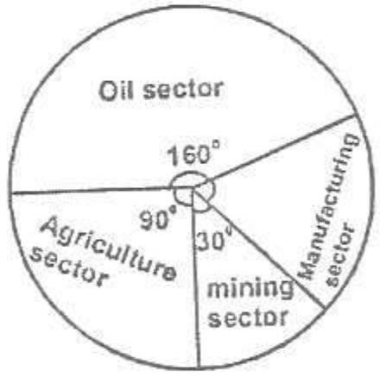

The percentage contribution of manufacturing sector is

* 1. 67.5
  2. 40.0
  3. 32.4
  4. 25.0

1. If the GDP is N60 billion, what is the difference between the contributions of oil and manufacturing sectors?
   1. N11.7 billion
   2. N13.3 billion
   3. N21.7 billion
   4. N26.6 billion
2. If the quantity of rice bought decreases from 250 tonnes to 200 tonnes owing to a 2% rise in price, it shows that there is a change in
   1. consumers' income
   2. demand
   3. consumers' tastes
   4. quantity damanded
3. A rise in income will, ceteris paribus, bring about
   1. a movement along the demand curve
   2. a leftward shift of the demand curve
   3. a rightward shift of the demand curve
   4. no effect on the demand curve

|  |  |
| --- | --- |
| Price (₦) | Quality (Kg) |
| 50 | 500 |
| 70 | 400 |

From the above, calculate the price elasticity of demand

* 1. 5.0
  2. 2.0
  3. 1.0
  4. 0.5

1. If the price of an item increases by 8% while the quantity demanded falls from 1500 units to 1492 units, the demand is said to be
   1. perfectly elastic
   2. inelastic
   3. elastic
   4. perfectly inelastic
2. Comparison of interpersonal utility is impossible because
   1. utility is measured in utils
   2. marginal utility is not observable
   3. utility is subjectively determined
   4. individual income differ
3. When the slope of the total utility curve is declining, the marginal utility of a consumer will be increasing if he
   1. stops consuming more of the commodity
   2. reduces the quantity consumed
   3. increases the quantity consumed
   4. consumes more of another commodity

## Use the diagram below to answer question 13 and 14

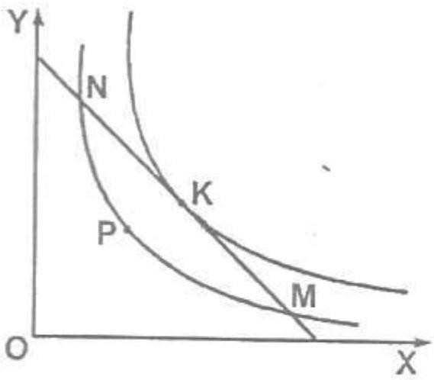

1. The consumer is at equilibrium at point

A. N

B. P

C. M

D. K

1. To move from point M to K, the consumer has to increase the
   1. consumption of X and reduce the consumption of Y
   2. expenditure on Y
   3. expenditure on X
   4. consumption of Y and reduce the consumption of X
2. The supply of cocoa is influenced by
   1. seasonal conditions
   2. the efficacy of fertilizer used
   3. the demand for beverages
   4. the availability of close substitutes
3. If quantity supplied is constant irrespective of price changes, the supply elasticity is
   1. unitary
   2. infinity
   3. fairly elastic
   4. perfectly inelastic
4. The cost elasticity of supply is a useful instrument for measuring
   1. profit
   2. productivity
   3. national income
   4. price index
5. The invisible hand promotes the interests of
   1. consumers
   2. society
   3. government
   4. producers
6. Fixing price above equilibrium will cause
   1. demand and supply to remain constant
   2. an increase in quantity supplied
   3. an increase in supply
   4. a decrease in quantity supplied
7. An important function of the price system is to
   1. ensure that producers' profits remain high
   2. guarantee full employment of resources
   3. allocate resources to most productive uses
   4. protect the economic interests of government
8. If all factors are variable in the long run,firms will experience
   1. decreasing returns to scale
   2. increasing returns to scale
   3. diminishing returns
   4. economies of scale
9. The equilibrium point of a firm is attained at the point where the isoquant is
   1. greater than the isocost
   2. less than the isocost
   3. tangent to the isocost
   4. greater than the output
10. The long-run average cost curve touches to the short-run average cost curves at the
    1. minimum points of all short run average cost curves
    2. declining points of all short-run average cost curves
    3. minimum point of only one of the short- run cost curves
    4. rising points of all short-run average cost curves
11. If a firm doubles all inputs in the long run and the total output is less than doubled, this results in
    1. diminishing returns
    2. constant returns to scale
    3. increasing returns to scale
    4. decreasing returns to scale
12. Patents and copyrights enable monopolists to
    1. determine the quality of their products
    2. determine the scale of their products
    3. restrict information flow to new firms
    4. restrict entry of new firms
13. A discriminatory monopoly is characterized by
    1. a common elasticity in different markets
    2. different elasticities in different markets
    3. a finite elasticity in all markets
    4. zero elasticity in all markets
14. Net National Product is derived by deducting
    1. net exports from GNP
    2. subsidies from GDP
    3. taxes from GDP
    4. depreciation from GNP

## Use the information below to answer question 28 29.

**The investment expenditure of economy changes by ₦2 Million and MPC is 0.75**

1. What is the change in income?
   1. N0.5m
   2. N1.5m
   3. N2.6m
   4. N8.0m
2. The multiplier is

A. 8

B. 4

C. 3

D. 2

1. The money that commands a higher market value than its face value is called
   1. paper money
   2. standard money
   3. commodity money
   4. fiat money
2. If a basket of commodities cost N120 in the base year and N240 in the current year, calculate the price index
   1. 100
   2. 200
   3. 240
   4. 300
3. The minimum amount which banks are required to deposit with the central bank is determined by the
   1. liquidity ratio
   2. cash reserve ratio
   3. minimum lending rate
   4. aggregate credit ceiling
4. The major function of money market is to
   1. provide funds for long-term financing
   2. provide funds short-term financing
   3. stabilize the value of the local currency
   4. stabilize domestic prices
5. An ad valorem tax is imposed on
   1. special commodities
   2. exports
   3. imports
   4. the value of a commodity
6. A huge national debt is an indication that the gold reserves of a nation has
   1. appreciated
   2. decreased
   3. depreciated
   4. stagnated
7. Rapid economic development in Nigeria is realizable by
   1. continuous dependence on oil
   2. concentrating more on agriculture
   3. developing the tourism industry
   4. diversifying the economy
8. The primary reason for desiring economic growth is to
   1. control inflation
   2. reduce poverty
   3. redistribute income
   4. raise standard of living
9. An emerging agricultural export crop in Nigeria is
   1. cassava
   2. cotton
   3. cocoa
   4. soya beans
10. A strategy for improving agriculture in Nigeria will involve
    1. controlling the prices of agricultural products
    2. ensuring self-sufficiency in food production
    3. reducing agricultural exports
    4. establishing commondity boards
11. A sugar industry is best located near the source of
    1. labour
    2. raw materials
    3. power
    4. capital
12. An important contribution of small-scale industries to the Nigerian economy is in the area of
    1. technological development
    2. foregin exchange earnings
    3. raw materials processing
    4. labour employment
13. A change in the pump price of petrol in Nigeria has a direct effect on the
    1. prices of consumer goods
    2. prices of essential goods
    3. cost of raw materials
    4. cost of transportation
14. Long-term funds for investment projects are sourced from the
    1. money market
    2. commodity market
    3. foreign exchange market
    4. capital market
15. A policy aimed at enhancing globalization of the Nigerian economy is
    1. indigenization
    2. dereglation
    3. commercialization
    4. privatization
16. The Malthusian theory was concerned about the relationship between
    1. population growth rates of the rich and the poor nations
    2. population density and national income
    3. population growth rate and natural resources
    4. age distribution of population
17. In a village of 50 persons, 10 immigrated, 25 died and 5 emigrated in year. Determine the total population
    1. 10
    2. 20
    3. 30
    4. 50
18. A deficit balance of payments is measured by subtracting the debits from the credits in the
    1. current account
    2. current and capital accounts
    3. current and escrow accounts
    4. capital and escrow accounts
19. One of the functions of ECOWAS is to
    1. provide funds for infrastructural development
    2. determine prices of exports
    3. redistribute income among citizens
    4. provide employment for citizens of member nations
20. The reward on machinery and equipment in the process of production is known as
    1. profit
    2. interest
    3. rent
    4. 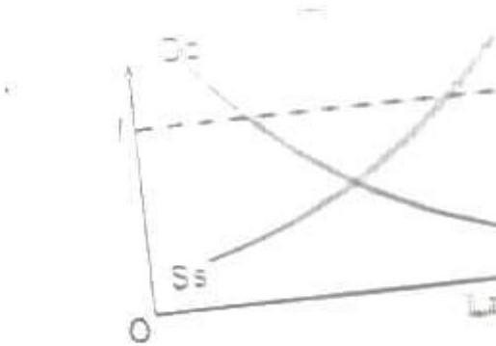wage s 50.

From this diagram, the minimum wage **OW**

will lead to

1. full employment of resources
2. unemployment
3. inflation
4. full employment of factors of production

4

**ANSWER KEYS:**

* 1. B **50.** D
  2. A
  3. B
  4. D
  5. B
  6. D
  7. B
  8. B
  9. A
  10. B
  11. A
  12. C
  13. A
  14. C
  15. B
  16. C
  17. B
  18. C
  19. A
  20. D
  21. B
  22. B
  23. D
  24. B
  25. B
  26. A
  27. D
  28. D
  29. D
  30. D
  31. C
  32. C
  33. C
  34. A
  35. D
  36. B
  37. C
  38. C
  39. A
  40. A
  41. B
  42. B
  43. D
  44. D
  45. B
  46. B
  47. D
  48. B
  49. D

# UTME 2013 ECONOMICS QUESTIONS

1. Which question paper type of Economics is given to you?
   1. Type B
   2. Type I
   3. Type B
   4. Type U
2. An economy in which both the public and private sectors contribute to economic growth is as
   1. feudal economy
   2. capitalist economy
   3. socialist economy
   4. mixed economy
3. If the standard deviation of a given data is 53, what is the variance?
   1. 2,082
   2. 2,809
   3. 2,808
   4. 2,209
4. Which of the following set of statistical tools is used for further economic analysis?
   1. the median and standard deviation
   2. the mean and mode
   3. the mean and standard deviation
   4. the mode and median
5. An advantage of the range as a measure of dispersion is that it
   1. can be used to calculate open- ended distribution
   2. make use of all values of observations in a distribution
   3. takes all values into consideration
   4. is useful for further statistical calculation
6. Find the median of the following set of data 35, 10, 14, 38, 15, 18, 22, 30 and

28

* 1. 10
  2. 38
  3. 35
  4. 22

1. An increase in demand without a corresponding change in supply will lead to
   1. a decrease in equilibrium price and increase in equilibrium quantity
   2. an increase in equilibrium price and quantity
   3. a decrease in equilibrium price and quantity
   4. an increase in equilibrium price and a decrease in equilibrium quantity
2. An increase in the price of a commodity will result in
   1. a decrease in the quantity demanded
   2. an increase in demand
   3. an increase in quantity demanded
   4. a decrease in demand
3. If the price of a bicycle changes from N120 to N80 and quantity bought changes from 300 to 500 units, the elasticity of demand for bicycle is
   1. 66.7
   2. 0.5
   3. 1.5
   4. 2.0
4. ​

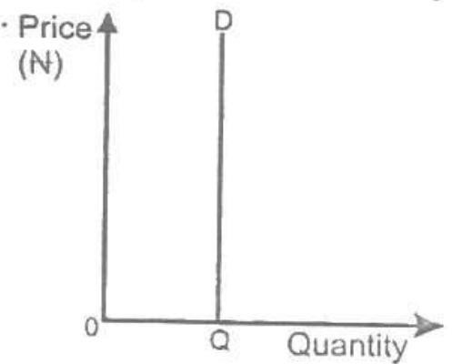

From the graph above, the price elasticity of demand is

* 1. unitarily elastic
  2. perfectly elastic
  3. perfectly inelastic
  4. fairly inelastic

1. One of the assumptions of the cardinalist approach is
   1. diminishing marginal rate of substitution
   2. the consistency and transitivity of choice
   3. that total utility depends on the quantity of the commodities consumed
   4. unstable marginal utility of money
2. Utility is the satisfaction derived from the
   1. distribution of goods and services
   2. use of goods and services
   3. demand of goods and services
   4. 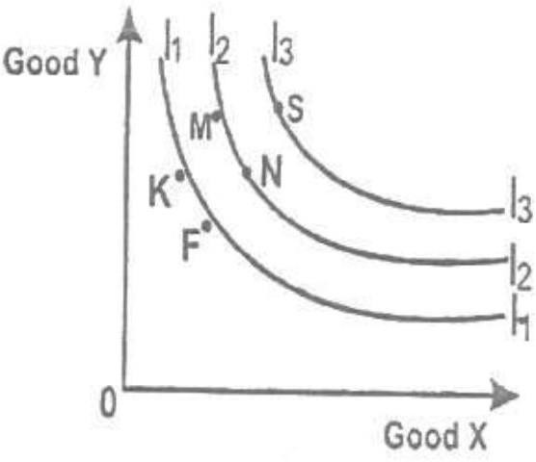production of goods and services 13.

From the indifference curve above, consumer will prefer combination

1. F
2. S
3. M
4. K
5. One of the major factors that brings about changes in supply is
   1. market discrimination
   2. availability of storage facilities
   3. the cost of storage
   4. incentives granted to workers
6. If P = 1 (Qs + 10). What is the quantity supplied at N14?

4

* 1. 14
  2. 60
  3. 46
  4. 32

1. If the supply of a product is elastic, a small reduction in price will
   1. reduce the cost of production
   2. reduce the quantity supplied
   3. increase the quantity supplied
   4. lead to no change in the quantity supplied
2. The supply of beverages by firms in a monopolistic market is an example of
   1. derived demand
   2. competitive supply
   3. composite supply
   4. joint demand
3. If the price of a commodity is fixed below equilibrium, this will lead to
   1. excess demand
   2. a decrease in price
   3. an increase in price
   4. excess supply
4. One of the criticisms of the price mechanism is that
   1. producers are sovereign
   2. it provides low degree of freedom
   3. it widens the inequitable gap
   4. consumers are sovereign
5. In Nigeria, government can reduce the cost of accommodation by fixing rent
   1. at the prevailing rate
   2. at the equilibrium price
   3. above the equilibrium price
   4. below the equilibrium price
6. If a refinery achieves a reduction in cost by purchasing and transporting crude oil in large quantities, it enjoys
   1. economies of scale
   2. specialization
   3. division of labour
   4. diseconomies of scale
7. An isoquant lying above to the right of another represents
   1. a higher output level
   2. constant returns to scale
   3. over-capacity utilization
   4. a lower output level 23.

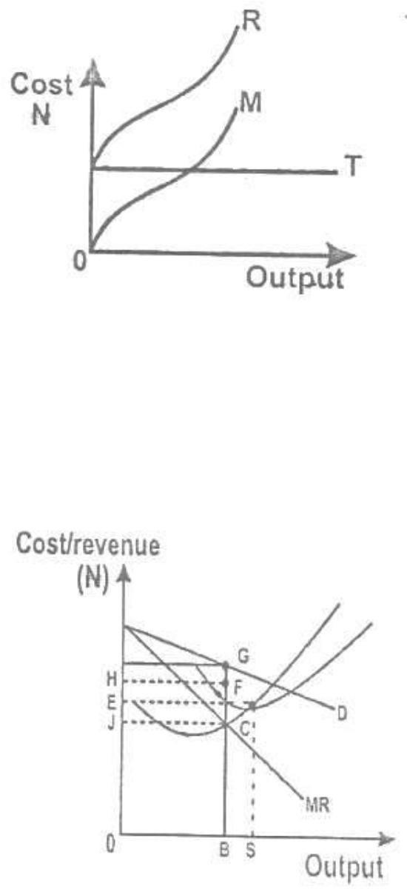

From the graph above, R represents

1. marginal cost
2. total cost
3. variable cost
4. fixed cost

**Use the graph below to answer question 24 and 25**

1. The optimum level of output of the firm is
   1. BC
   2. OB
   3. OS
   4. BS
2. The total revenue of the firm is represented by
   1. GHEF
   2. GHJC
   3. EFJC
   4. GHOB
3. A measure of national income used as comparison of standard of living among nations is
   1. net national product
   2. gross domestic product
   3. gross national product
   4. per capita income
4. The speculative demand for money is inversely related to the
   1. interest rate
   2. level of income
   3. exchange rate
   4. inflation rate
5. If Mr. K obtains a N50.000 loan from a bank for the purpose of providing household needs, the demand for money is said to be
   1. transactionary
   2. speculative
   3. precautionary and speculative
   4. transactional and speculative
6. Which of the following is used by the Central Bank of Nigeria to control inflation?
   1. Tariff on imports
   2. Tax rate
   3. Exchange rate
   4. Discount rate
7. If CBN reduces money supply, the interest rate will
   1. fluctuate
   2. rise
   3. fall
   4. remain unchanged
8. An example of an expansionary fiscal policy action is
   1. decrease in the corporate profit tax rates
   2. decrease in welfare payments
   3. purchase of government securities
   4. decrease in the bank rate
9. A tax on land will ultimately fall
   1. partly on agents and users
   2. entirely on users
   3. entirely on owners
   4. partly on users and owners
10. One of the goals of development plans in Nigeria is to
    1. increase the profitability of multinational businesses
    2. improve the country's GDP
    3. achieve higher standard of living for the citizens
    4. deregulate the economy
11. Life insurance companies contribute to economic development by holding a part of their assets in
    1. long-term financial instruments
    2. money market instruments
    3. cash and near money
    4. short-term financial instruments
12. In order to add value to Nigeria agricultural produce, there is need to
    1. cultivate high breed crops
    2. process them into finished goods
    3. adopt modern storage methods
    4. advertise them in European markets
13. The main reason for low agricultural produce in west Africa is need to
    1. the presence of large-scale agro- allied industries
    2. high dependency ratio
    3. over dependence on agriculture for subsistence
    4. the use of crude implements in farming process
14. The most important determinant for the location of a brick industry is the availability of
    1. market
    2. power supply
    3. water
    4. raw materials
15. In Nigeria, efficiency in public corporations can be achieved through
    1. public offer
    2. indigenization
    3. privatization
    4. nationalization
16. Government participation in the oil industry was necessitated by the
    1. annual increase in production
    2. formation of OPEC
    3. high demand for crude oil
    4. huge investment outlay
17. The deregulation of the petroleum sector in Nigeria will bring about
    1. efficiency in pricing and distribution of the products
    2. an end to the importation of fuel
    3. an end to foreign firms' dominance
    4. fixing appropriate production quotas
18. A distinguishing characteristic of consumer co-operative society is that the
    1. the maximum number of shareholders is 20
    2. members are the owners
    3. members are the workers
    4. the minimum number of shareholders is 5
19. A major disadvantage of partnership business is
    1. difficulty in the transfer of shares
    2. distrust among members
    3. limited liability
    4. large capital outlay
20. The quality of labour force in Nigeria can be improved by
    1. establishing more tertiary institutions
    2. creating sufficient job opportunities
    3. encouraging the study of science and technology
    4. establishing more skills acquisition centres
21. The effect of emigration on a country's population is
    1. decrease in the population
    2. decrease in job opportunities
    3. increase in population
    4. increase in dependency ratio
22. A measure for preventing the external value of the naira from falling is for the government to

|  |
| --- |
| A. increase its spending with foreign |
| Reserve |
| B. sell its own currency |
| C. reduce interest rate |
| D. buy its currency with foreign reserve |
| 46. A fiscal policy instrument that can |
| influence the demand pattern in an |
| economy is |
| A. government spending |
| B. interest rate |
| C. income tax |
| D. tariff |
| 47. One of the main achievements of the |
| Economic Commission for Africa is |
| A. eliminating trade restrictions among |
| States |
| B. encouraging transport and |
| communication development |
| C. guaranteeing a steady flow of foreign |
| investment into Africa |
| D. providing the machinery for |
| collaboration on monetary issues |
| 48. The rate of interest change on loans |
| depends largely on |
| A. the prevailing exchange rate |
| B. marginal efficiency of capital |
| C. the risk associated with the loan |
| D. the prevailing tax rate |
| 49. A valid explanation for real wage growth |
| Is |
| A. an increase in the rate of productivity |
| B. the rising cost of capital accumulation |
| C. a contraction of employment in service |
| industries |
| D. an increase in the quantity of labour |
| 50. If Mr. X lost his clerical job at a store |
| and searched for a similar job for ten |
| months before finding one this implies |
| that Mr. X was |
| A. structurally unemployed |
| B. frictionally unemployed |
| C. seasonally unemployed |
| D. cyclically unemployed |

**ANSWER KEYS:**

|  |  |
| --- | --- |
| **1.** | D |
| **2.** | D |
| **3.** | B |
| **4.** | B |
| **5.** | A |
| **6.** | D |
| **7.** | B |
| **8.** | A |
| **9.** | D |
| **10.** | C |
| **11.** | C |
| **12.** | B |
| **13.** | B |
| **14.** | C |
| **15.** | C |
| **16.** | C |
| **17.** | C |
| **18.** | A |
| **19.** | D |
| **20.** | C |
| **21.** | A |
| **22.** | A |
| **23.** | C |
| **24.** | B |
| **25.** | D |
| **26.** | D |
| **27.** | A |
| **28.** | D |
| **29.** | B |
| **30.** | B |
| **31.** | A |
| **32.** | C |
| **33.** | C |
| **34.** | C |
| **35.** | D |
| **36.** | D |
| **37.** | A |
| **38.** | C |
| **39.** | B |
| **40.** | A |
| **41.** | B |
| **42.** | B |
| **43.** | D |
| **44.** | A |
| **45.** | B |
| **46.** | C |
| **47.** | A |
| **48.** | C |
| **49.** | A |
| **50.** | B |

# UTME 2014 ECONOMICS QUESTIONS

1. Which question paper type of Economics is given to you?
   1. Type F
   2. Type E
   3. Type L
   4. Type S
2. The choice of how to produce in a command economy is determined by
   1. government
   2. consumer
   3. industrialists
   4. labour unions
3. In capitalist economies, questions about what to produce are ultimately answered by
   1. income level of households
   2. available technical skills in the economy
   3. output decisions of firms
   4. holding decision of households
4. The best measure of dispersion to determine the tallest tree in a forest is
   1. range
   2. variance
   3. standard deviation
   4. mean deviation
5. What is the percentage contribution of services to the national income?
   1. 15%
   2. 10%
   3. 54%

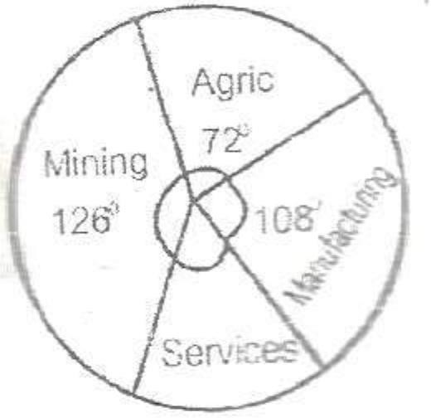

* 1. 24%

1. If the national income is 360m, the contribution of the manufacturing sector is
   1. 312m
   2. 39m
   3. 318m
   4. 317m

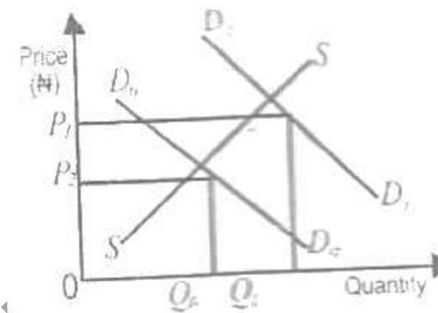

A combination of factors responsible for a shift from D0D0to D1D1 are

* 1. consumers income and change in technology
  2. price of the commodity and weather conditions consumers income and population size
  3. consumers taste and change in price

1. Given that Qd = 40-2P and Qs = 6P+24. Calculate the equilibrium price.
   1. ₦34
   2. ₦32
   3. ₦36
   4. ₦16
2. A change in demand for a normal goods implies that, there is a
   1. change in the quantity demanded as price changes
   2. shift in the demand curve
   3. movement along a given demand curve
   4. change in the price elasticity of demand
3. If a 10% rise in price causes a 5% decrease in the quantity demanded of a commodity, the elasticity demand is
   1. unitary elastic B.
4. 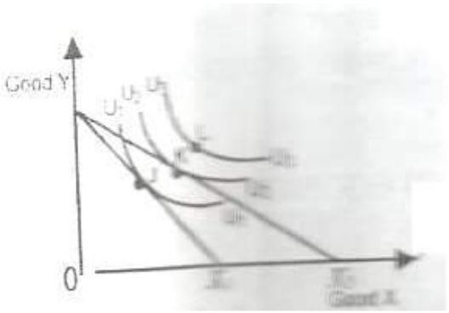​

From the graph above, the consumer will attain equilibrium at point

A. J

B. K

C. L

D. M

1. A rightward shift of the budget line is caused by a
   1. fall in consumer income
   2. change in consumer taste
   3. fall in the commodity relative price
   4. rise in the commodity relative price
2. Given the supply function P = 1/4(Qs+10) when P = N10, what is Qs?
   1. 20
   2. 15
   3. 50
   4. 30
3. ​

Price Quantity

(₦) supplied

8 20

10 24

From the table above, Calculate the price elasticity of supply

1. 0.50
2. 0.80
3. 2.00
4. 1.25
5. When price is set below equilibrium, this will lead to
   1. an increase in the quantity supplied
   2. a new equilibrium
   3. a decrease in the quantity supplied
   4. a fall in price
6. Price mechanism determines the prices of commodities through
   1. auctioning
   2. market forces
   3. the sales of treasury bills
   4. government legislation 17.

|  |  |  |  |
| --- | --- | --- | --- |
| Unit | Total | Average | Marginal |
| of | product | product | product |
| labour |  |  |  |
| 1 | 8 | 8 | -- |
| 2 | 20 | 10 | 12 |
| 3 | E | 9 | 7 |
| 4 | 28 | 7 | F |
| 5 | 40 | 8 | 12 |

From the table above, find the values of E and F respectively

1. 27 and 1
2. 68 and 12
3. 28 and 5
4. 12 and 19
5. If the production of a large firm is higher than that of a small firm, it is experiencing.
   1. external economies of scale
   2. external diseconomies of scale
   3. internal economies of scale
   4. internal diseconomies of scale
6. Division of labour requires that, the tasks in a production line be performed
   1. by specialists
   2. in stages
   3. by all workers
   4. by unskilled labourers
7. Given that FC = ₦500, VC = ₦1,500, and Q = 50 units. Find the average cost of the product.
   1. ₦30
   2. ₦40
   3. ₦10
   4. ₦20
8. Rent and administrative expenses are examples of
   1. average fixed costs
   2. average variable costs
   3. fixed costs
   4. variable costs
9. A perfect competitor will continue to expand output up to the point where
   1. TC>TR
   2. MR=AR
   3. MC<MR
   4. MC>MR
10. One of the characteristics of a monopolist is that, he can influence
    1. quantity produced by other producers
    2. prices charged by other producers
    3. both price and quantity
    4. price or quantity
11. A monopolist can boost up his revenue by
    1. adjusting both price and output upward
    2. reducing total output to match price
    3. increasing price
    4. reducing price
12. Which of the following can be used to measure the Gross National product in an open economy?
    1. C+I+G+(X+M)
    2. C+I+G+X
    3. C+I+G

3

* 1. C+I+G+(X-M)

1. If MPC = 2/3 and investment is ₦100 million, the level of national income is
   1. ₦100 million
   2. ₦10 million
   3. ₦303 million
   4. ₦300 million
2. The precautionary demand for money is determined by
   1. the rate of interest
   2. the level of savings
   3. the level of income
   4. general price level
3. An inflation that co-exists with high rate of unemployment is
   1. hyperinflation
   2. stagflation
   3. demand-pull inflation
   4. cost-push inflation
4. One of the challenges facing the banking industry in Nigeria is
   1. ensuring technological security
   2. providing employment
   3. providing loans for investment
   4. creating more money
5. Short-term loans for investment are usually obtained through the
   1. stock market
   2. development banks
   3. money market
   4. capital market
6. Given a base year and the price index of 175% the following year, which of the following year will arise?
   1. The cost of living decreases of that year
   2. The cost of living remains unchanged
   3. The value of money rises by 75%
   4. The value of money falls by 75%
7. Wage freeze is a policy measure aimed at
   1. encouraging investors
   2. curbing inflation
   3. regulating standard of living
   4. curbing deflation
8. A major obstacle to the development of Nigeria economy is
   1. low capital formation
   2. rural-urban migration
   3. over dependence on oil
   4. poor developmental policies
9. A major feature of an underdeveloped economy is
   1. excess capacity utilization
   2. low rate of population growth
   3. low level of standard of living
   4. low level of unemployment
10. An important role of agriculture in Nigeria's economic development is the
    1. processing of raw materials for industries
    2. regulation of price system
    3. provision of infrastructure
    4. provision of employment
11. An advantage of large-scale farming over peasant farming is in the area of
    1. providing research and massive employment of labour
    2. redistributing national income to various regions of the country
    3. encouraging the use of traditional implements
    4. encouraging urban-rural migration
12. A major disadvantage of localization of industry is
    1. the risk of structural unemployment
    2. over-utilization of installed industrial capacity
    3. the risk of seasonal unemployment
    4. under-utilization of installed industrial capacity
13. One major factor that determines the location of an industry is
    1. tax exemption grant
    2. its proximity to the market
    3. the capital base
    4. the social responsibility of the firm
14. The major contribution of OPEC to the Nigerian economy is the
    1. provision of social infrastructures
    2. granting of subsidies on petroleum products
    3. stabilization of oil prices
    4. building of refineries
15. The loading of crude oil at the terminal is an activity in the
    1. downstream sector of the oil industry
    2. upstream and downstream sector of the oil industry
    3. upstream sector of the oil industry
    4. midstream and upstream sectors of the oil industry
16. The short-run average variable cost of a firm will rise owing to
    1. the expansion of factory space
    2. the building of new warehouse
    3. an increase in the cost of labour
    4. an increase in the salaries of directors
17. Firms embark on vertical integration in other to
    1. take over markets formally controlled by other firms
    2. prevent other firms from entering the market
    3. reduce advertisement and management cost
    4. enjoy economies of large- scale production
18. The voting power in co-operative societies is vested on
    1. management
    2. members without loan
    3. shareholders
    4. members with the highest contribution
19. An accurate census figure is an important tool for planners in
    1. providing employment
    2. siting industries
    3. providing social amenities
    4. allocating resources
20. An accurate population census is important in other to
    1. produce more food for the growing population
    2. provide employment opportunities for the people
    3. estimate a country's per capita income
    4. fast track industrial development
21. A major determinant of floating exchange rate is
    1. the highest denomination of the currency
    2. an Act of the parliament
    3. the system of government
    4. the forest of demand and supply
22. If the importation of a commodity is limited to a definite quantity, the trade control measure imposed is
    1. excise duties
    2. import duties
    3. quotas
    4. tariff
23. The main objective of WTO is to
    1. ensure adequate protection of infant industries
    2. provide a mechanism for tariff reduction
    3. assist countries with chronic balance of payments problem
    4. assist developing countries to execute developmental projects
24. The major determinant of the total volume of output in an economy is the
    1. level of total expenditure
    2. composition of consumer spending
    3. number of farmers
    4. size of the labour force
25. The labour force of a country is determined by the
    1. age structure of the population
    2. geographical distribution of the population
    3. sex distribution of the population
    4. number of people available for work

|  |  |  |  |  |  |
| --- | --- | --- | --- | --- | --- |
| **1.** | C | **9.** D |  | **17.** | C |
| **2.** | A | **10.** | C | **18.** | C |
| **3.** | C | **11.** | B | **19.** | B |
| **4.** | B | **12.** | D | **20.** | D |
| **5.** | C | **13.** | A | **21.** | D |
| **6.** | C | **14.** | B | **22.** | C |
| **7.** | D | **15.** | D | **23.** | C |
| **8.** | D | **16.** | B | **24.** | B |

|  |  |  |  |  |  |  |  |
| --- | --- | --- | --- | --- | --- | --- | --- |
| **ANSWER KEYS:** | | | | | | | |
| **25.** | C | **33.** | C | **41.** | C | **49.** | A |
| **26.** | D | **34.** | C | **42.** | D | **50.** | B |
| **27.** | A | **35.** | D | **43.** | C |  |  |
| **28.** | A | **36.** | A | **44.** | C |  |  |
| **29.** | C | **37.** | D | **45.** | D |  |  |
| **30.** | B | **38.** | B | **46.** | D |  |  |
| **31.** | A | **39.** | C | **47.** | A |  |  |
| **32.** | B | **40.** | B | **48.** | D |  |  |

# UTME 2015 ECONOMICS QUESTIONS

1. The major implication of high dependency ratio on an economy is
   1. high capital formation
   2. vicious cycle of poverty
   3. low cost of living
   4. high standard of living.
2. One of the major problems of agricultural sector in Nigeria is
   1. low literacy level of farmers
   2. small size of farms
   3. pest attack on crops
   4. inadequate modem farm implements.
3. Cooperative societies are characterized with
   1. divergent interest of members
   2. limited liability
   3. free entry and exit
   4. unlimited size of membership.
4. The marginal propensity to save measures the
   1. ratio of change in saving
   2. change in supply as a result of a change in consumption
   3. ratio of change in consumption to a change in the level of income
   4. average propensity to consume.
5. Structural unemployment is mainly caused by
   1. a change in the consumption pattern
   2. a change in the business cycle
   3. decrease in the output level
   4. Seasonal variation.
6. One of the major problems of census in Nigeria is
   1. inadequate skilled personnel
   2. high dependency ratio
   3. distortion of census figures
   4. High cost of conducting census.
7. A decrease in government expenditure in an economy will cause general price level to
   1. remain constant
   2. fluctuate
   3. fall
   4. Rise.

|  |  |  |  |
| --- | --- | --- | --- |
| Unit of | TP | AP | MP |
| labour |
| 1 | 6 | 6 | -- |
| 2 | 14 | 7 | 8 |
| 3 | K | 9 | 13 |
| 4 | 40 | 10 | F |

From the table above, find the values of K and F respectively

* 1. 13 and 27
  2. 27 and 13
  3. 10 and 27
  4. 27 and 10.

1. In the theory of consumer behaviour, the sum of all marginal utilities is
   1. average marginal utility
   2. the initial marginal utility
   3. total utility
   4. diminishing marginal utility.
2. In a pure capitalist economy, the means and forces of production are owned and controlled by the
   1. public and private sectors
   2. feudal lords
   3. public sector
   4. private sector.
3. A factor earning which is paid out as unemployment benefit is referred to as
   1. interest rate
   2. direct rate
   3. eco
4. From the graph above, FG indicates
   1. equilibrium quantity demanded
   2. excess supply
   3. equilibrium quantity supplied
   4. Excess demand.
5. The demand for money is referred to as the
   1. amount of money in fixed deposit
   2. desire to hold money intangible assets
   3. need for money to invest
   4. Desire to hold money in liquid form rather than investing it.
6. In the theory of production, a producer is at equilibrium at a point where
   1. isocost is above the isoquant curve
   2. isoquant is below the isocost curve
   3. isocost is tangent to the marginal revenue
   4. isoquant is tangent to the isocost curve.
7. Balance of trade shows the relationship between the
   1. internal and external trade
   2. total value visible import and Export
   3. deficit and surplus balance of payments
   4. total value of invisible import and export.
8. If the cash reserve ratio is 30%, a new deposit of ₦20 million will increase supply by
   1. ₦57.8m
   2. ₦47.9m
   3. ₦69.78m
   4. ₦66.7m.
9. A fall in the price c f ostentatious goods will
   1. increase the quantity demanded
   2. decrease the quantity demanded
   3. decrease demand
   4. increase demand.
10. Payment of interests on loans and the repayment of capital sum at a future date is
    1. balance debt
    2. debt servicing
    3. debt relief
    4. debt retaking.
11. The most difficult measure of central tendency to determine in a grouped data is
    1. range
    2. variance
    3. mean
    4. mode.
12. Localization of industry is mainly determined by
    1. diseconomies of scale
    2. population growth
    3. division of labour
    4. access to raw materials.
13. Geographical distribution of a population is affected by
    1. low birth rate
    2. the availability of skilled manpower
    3. the availability of agricultural land
    4. high birth ratenomic rent
    5. transfer payment.
14. A tax burden on a commodity will be shared equally if the demand is
    1. fairly elastic
    2. perfectly inelastic
    3. fairly inelastic
    4. unitary elastic.
15. Higher income taxes can be used to control
    1. demand-pull inflation
    2. high interest rates
    3. cost- push inflation
    4. hyperinflation.

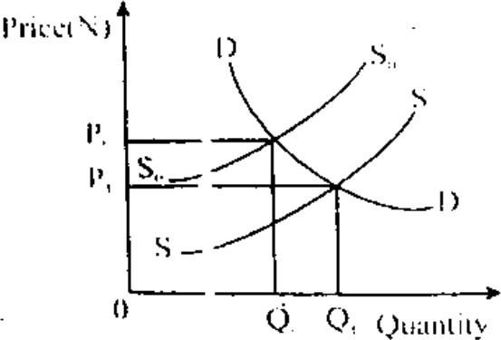

From the graph above, a shift of the Supply curve from S0S0, to S1S1 will lead to

* 1. a decrease in price and quantity
  2. no change in price and quantity
  3. an increase in price and quantity
  4. a decrease in price and an increase in quantity.

1. An indifference map is made up of a set of
   1. consumers' total utility
   2. consumer surplus
   3. budget lines
   4. indifference curves.
2. Recapitalization policy will enable commercial banks to
   1. employ more qualified workers
   2. open more branches
   3. reduce interest rate
   4. have a very strong capital base
3. The number of persons required to form a private company ranges from
   1. ten to twenty
   2. two to fifty
   3. two to seven
   4. seven to ten.
4. The major function of international monetary funds is the
   1. provision of short-run loans to medium scale industries
   2. provision of long-term loans for infrastructure
   3. development of agriculture in member countries
   4. maintenance of stable exchange rates
5. One of the major activities in the upstream sector of the Nigeria petroleum industry includes
   1. transportation of finished products
   2. refining of crude oil
   3. marketing of refined petrol
   4. exploration of crude oil.
6. The law of supply states that the
   1. higher the price the higher the quantity supplied
   2. quantity supplied is always equal to the quantity demanded
   3. lower the price the higher the quantity supplied
   4. higher the price the lower the quantity supplied.
7. One of the features of a perfect competitive firm is
   1. restrictions to entry and exit
   2. price discrimination
   3. absence of transportation cost
   4. product differentiation.
8. The basis for international trade is the
   1. differences in natural resources endowment
   2. differences in the population size
   3. prevailing interest rate on multilateral loans
   4. economic system in practice.
9. Training farmers on the improved farming techniques is the major activity of
   1. intermediate workers
   2. middlemen
   3. extension workers
   4. creditors.
10. In a free market economy, prices are determined by
    1. consumers
    2. producers
    3. the central government
    4. the forces of demand and supply.
11. The basic economic problem of what to produce in an economy is determined by
    1. the availability of labour
    2. the means of distribution
    3. the availability of resources
    4. technological know-how.
12. In Nigeria, a fall in the supply of petrol would generally affect the
    1. import of goods and services
    2. export of goods and services
    3. general price level in the country
    4. exchange rate of the Naira.
13. The short-run equilibrium point of a perfectly competitive firm is attained at a point where
    1. is equal to total cost
    2. the demand curve is tangential to the marginal cost
    3. the marginal cost curve is equal to the marginal revenue curve
    4. the marginal cost is equal to the price of the firm.
14. Government can protect consumers from exploitative prices by introducing
    1. minimum price
    2. price differentiation
    3. price floor
    4. maximum price.
15. If a fall in the price of commodity K brought about an increase in the demand for commodity Y, the two commodities are
    1. composites
    2. derived in nature
    3. substitutes
    4. c implements.
16. In the theory of production, the price of a factor input is determined by
    1. the prevailing exchange rates
    2. its elasticity of demand
    3. the existence of large market
    4. 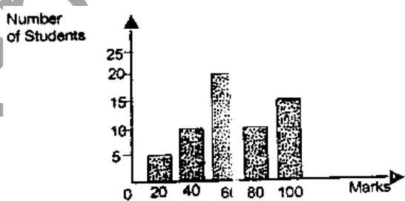the prevailing interest rates. 41.

From the graph above, find the modal score

1. 40
2. 20
3. 100
4. 60.
5. When the selling price of a monopolist is below his short-run marginal cost, he is said to be making
   1. an economic profit
   2. Losses
   3. profit
   4. supernormal profit.
6. The overall economic performance of a country can be assessed through
   1. overlooking of its agricultural sector
   2. employment estimates
   3. national income estimates
   4. balance of payment.
7. The supply of agricultural products is mainly determined by
   1. consumers' taste
   2. consumers' income
   3. technology
   4. consumers.
8. Determine the median of 6 10, 5, 12,

20, 18, 20 and 4

* 1. 11
  2. 9.67
  3. 12.56
  4. 12.

1. ​

|  |  |  |  |  |  |  |
| --- | --- | --- | --- | --- | --- | --- |
| X | 10- | 21- | 31- | 41- | 51- | 61- |
| 20 | 30 | 40 | 50 | 60 | 70 |
| F | 4 | 6 | 10 | 50 | 3 | 5 |

From the table above, find the range of the distribution

* 1. 50
  2. 11
  3. 70
  4. 59.

1. The failure of the Nigeria industrial sector is mainly associated with
   1. lack of raw materials
   2. inadequate market for industrial goods
   3. underdeveloped infrastructural facilities
   4. inadequate capital.
2. If Qd = 40-4P and P = N4, what is the quantity demanded?
   1. 30
   2. 32
   3. 24
   4. 26.
3. The long-run total cost curve shows the cost of
   1. all fixed factors of production
   2. the average fixed cost
   3. all factor inputs that are employed
   4. variable factors of production.
4. The supply of farm produce is mainly determined by
   1. consumers’ income
   2. weather condition
   3. population
   4. consumers’ taste

**ANSWER KEYS**

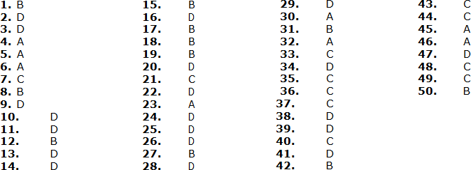

# UTME 2016 ECONOMICS QUESTIONS

1. A country embarks on deficit financing in order to
   1. reduce aggregate demand
   2. increase revenue
   3. stimulate investment
   4. curb inflation
2. The money market provides business firms with the avenue to
   1. purchase goods and services
   2. purchase capital equipment’s
   3. obtain short- term funds
   4. obtain long-term funds
3. The optimum level of output for pure monopolist occurs where
   1. P is highest
   2. P=AC
   3. P=MC
   4. MR=MC
4. According to the demographic transition theory, Africa can be said to be at stage
   1. 2 and 3
   2. 3 only
   3. 2 only
   4. 1 and 3
5. The Economic Community of West African States (ECOWAS) is an example of
   1. globalization
   2. regional marketing board
   3. economic integration
   4. economic union.
6. Given: 32, 18, 24, 17, 16, 32, 28, 68, 71

and 15, the mode of the distribution is

* 1. 71
  2. 56
  3. 32
  4. 15

1. The major determinant of income elasticity of demand is
   1. government policy
   2. the availability of substitutes
   3. the price of the good
   4. the level of consumer's income
2. Given: 2, 4, 6, 8, 4 and 6, the absolute mean deviation is
   1. 6.00
   2. 1.67
   3. 30.00
   4. 0.60
3. The precautionary demand for money is determined by
   1. the level of savings
   2. the rate of interest
   3. general price level
   4. the level of income.
4. If the output of a firm experiencing economies of scale increases, the average cost would
   1. be at minimum
   2. rise
   3. be at maximum
   4. fall.
5. The demand curve for a normal good is negatively sloped because
   1. price is an incentive to producers
   2. price is an incentive to consumers
   3. demand always exceeds supply
   4. price and quantity move in the same direction.
6. ​

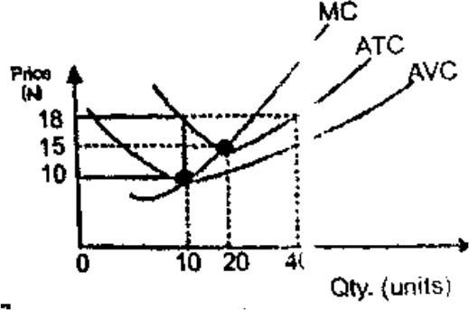

The average total cost when 20 units are produced is

* 1. ₦45.30kg
  2. ₦50.00kg
  3. ₦47.50kg
  4. ₦5.00kg

1. The major role of multinational companies in the Nigerian petroleum industry is
   1. oil marketing only
   2. oil marketing and prospecting
   3. establishment of refineries
   4. oil prospecting only.
2. Life insurance companies contribute to economic development by holding a part of their assets in
   1. long-term financial instruments
   2. equipment
   3. cash and near money
   4. money-market instruments.
3. The wage rate is mostly related to

A. marginal productivity of labour B. average productivity of labour C. marginal efficiency of investment D. total productivity of Labour.

1. The choice of how to produce in a command economy is determined by
   1. consumers
   2. government
   3. industries
   4. labour unions.
2. The co-efficient of price elasticity of supply is
   1. % change in supply

% change in price

* 1. % change in quantity supplied % change in price

D. % change in quantity supplied %change in income

D. % change in quantity demanded

%change in income

1. A change in supply of a commodity is due to a change in the
   1. price of the commodity
   2. cost of production
   3. price of substitute
   4. population growth rate.
2. In a limited liability company, the greatest risk is borne by the
   1. preference shareholders
   2. debentures shareholders
   3. ordinary shareholders
   4. board of directors.
3. A market characterized by absence of close substitutes of goods and services is an example of
   1. a monopoly
   2. an oligopoly
   3. a perfect competition
   4. a monopolistic competition.
4. An inflation that co-exists with high rate of unemployment is
   1. hyperinflation
   2. cost-push inflation
   3. stagflation
   4. demand-pull inflation.
5. The growth and development of small and medium scale enterprises in Nigeria is hampered by
   1. poor regulatory framework
   2. poor access to credit facilities
   3. poor management
   4. the small size of the market.
6. A major determinant of demand is
   1. incentives to workers
   2. level of technology
   3. population
   4. cost of production.
7. Which of the following can be used to measure the Gross National Product
   1. C+I+G-F(X+M)
   2. C+I+G+(X-M)
   3. C+I+G+X
   4. C+I+G
8. Find the median of the following set of data 35, 10, 14, 38, 15, 18, 22, 30 and

28.

* 1. 10
  2. 22
  3. 38
  4. 35

1. ​

|  |  |
| --- | --- |
| Unit of | Total |
| Capital | output(kg) |
| 1 | 13 |
| 2 | 43 |
| 3 | 123 |
| 4 | 243 |
| 5 | 353 |
| 6 | 483 |
| 7 | 563 |
| 8 | 663 |

From the table above, determine the average product of the 5th unit of capital

* 1. 310.5
  2. 176.5
  3. 70.6
  4. 62.0

1. The problem of what to produce is determined by
   1. consumption pattern
   2. the distribution pattern
   3. the state of technology
   4. the volume of production
2. The main function NNPC is to
   1. develop the oil producing areas
   2. oversee the development of the oil sector
   3. ensure regular supply of products
   4. fix the prices of petroleum products
3. A major feature of an underdeveloped economy is
   1. low rate of population growth
   2. excess capacity utilization
   3. low level of unemployment
   4. low level of standard living.
4. A tax on land will ultimately fall
   1. partly on agents and users
   2. partly on users and owners
   3. entirely on owners
   4. entirely on users.
5. The deregulation on the petroleum sector in Nigeria will bring about
   1. efficiency in pricing and distribution of the products
   2. fixing appropriate production quotas
   3. an end to the importation of fuel
   4. an end to foreign firms' dominance.
6. One of the ways of correcting a deficit balance of payments is to
   1. devalue a country's currency
   2. predenominate a country's currency
   3. reduce imports
   4. reduce exports.
7. A nation's net export is negative when her
   1. export is adjusted upwards
   2. external reserves deplete
   3. depreciation exceeds investments
   4. imports exceeds exports.
8. Given: Qd = 30 — 3P and Qs = 9P —

15, determine the equilibrium price

* 1. ₦12.00
  2. ₦3.75
  3. ₦2.80
  4. ₦3.00

1. The problem of economic development in Nigeria is that of
   1. poor weather conditions
   2. overpopulation
   3. surplus skilled manpower
   4. inadequate infrastructure.
2. The combination of two commodities that yield the same level of satisfaction is illustrated by
   1. a budget line

40.

From the table above, the marginal product of the 7th Unit of Capital is

|  |  |
| --- | --- |
| Unit of | Total |
| capital | output(kg) |
| 1 | 13 |
| 2 | 43 |
| 3 | 123 |
| 4 | 243 |
| 5 | 353 |
| 6 | 483 |
| 7 | 563 |
| 8 | 663 |

* 1. an isocost curve
  2. a production possibility curve
  3. an indifference curve

1. The demand for inferior goods is inversely related to change in
   1. income
   2. price
   3. supply
   4. taste.
2. The minimum number of shareholders for partnership is

A. 7

B. 4

C. 2

D. 3

1. When diminishing returns sets in, the total variable cost begins to
   1. rise at an increasing rate
   2. fall at a decreasing rate
   3. rise at a decreasing rate
   4. fall at an increasing rate.
2. 80kg
3. 100kg
4. 310kg
5. 173kg
6. Given: 32, 18, 24, 17, 16, 32, 28, 68,

71 and 15, what is the range?

* 1. 26
  2. 32
  3. 56
  4. 68

1. ​

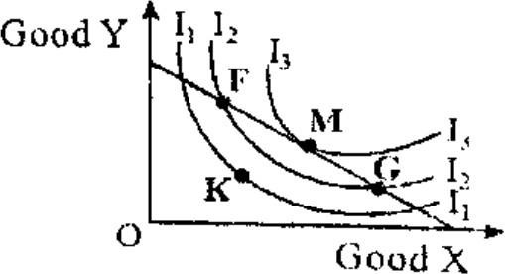

From the diagram above, the consumer is at equilibrium at point

A. G

B. F

C. K

D. M

1. If P = 1/4 (Qs + 30), what is the quantity supplied at ₦18?
   1. 64.5
   2. 42.0
   3. 2.4
   4. 30.0
2. When a consumer is at equilibrium, The MRS x is equal to the
   1. product of the two prices
   2. sum of the two prices
   3. ratio of the two prices
   4. difference of the two prices.
3. One of the major factors militating against industrialization in Nigeria is
   1. low level of foreign investment
   2. frequent break-down of equipment
   3. inadequacy of infrastructural facilities
   4. government participation.
4. One of the factors that is considered in the location of a cement industry is nearness to
   1. market
   2. raw materials
   3. infrastructural facilitates
   4. skilled manpower.

B. instability in demand for the products

C. dominance of multinationals

D. declining oil reserves.

1. At full employment level, a contractionary monetary policy will Lead to a
   1. rise in aggregate supply
   2. rise in aggregate demand
   3. rise in level of inflation rate
   4. fall in the level of inflation
2. A country where the available population is unable to guarantee efficient utilization of available resources is experiencing
   1. under population
   2. over-population
   3. high population density
   4. optimum population.
3. One of the causes of instability in farmers' income is
   1. high level of illiteracy
   2. unfriendly land tenure
   3. unfavourable weather condition
   4. poor management of extension services

|  |
| --- |
| 47.A problem facing the development of the |
| Nigerian Petroleum industry in Nigeria is |
| A. persistent gas flaring |

**ANSWER KEY**

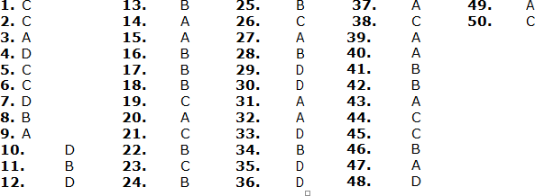

# UTME 2017 ECONOMICS QUESTIONS

1. If the arithmetic mean of 2, 3, 5, 8, Z, 10 and 12 is 7, what is the value of Z?
   1. 8
   2. 9
   3. 10
   4. 7
2. The most important function of agriculture to the Nigerian economy is
   1. the guarantee of food security
   2. technical skill development
   3. technological development
   4. industrial development
3. Given that Qd=15-2P and Qs=5+3P, determine the equilibrium price.
   1. N3.00
   2. N5.00
   3. N2.00
   4. N6.00
4. Scale of preference is referred to as the
   1. choices consumers make
   2. array of consumer's needs
   3. consumer preference for luxurious goods
   4. consumer wants in order of priority
5. One of the basic assumptions of monopoly is
   1. perfect information of the market condition
   2. the ability to either control price or output
   3. perfect mobility of factors of production
   4. large number of buyers and sellers
6. The major advantage of a public limited liability company over a private limited liability company's
   1. limited liability enjoyed by owner
   2. separate legal entity
   3. easy transferability of shares
   4. perpetual existence
7. The main activity in the upstream oil sector in Nigeria is
   1. marketing of petroleum products
   2. distribution of petroleum products
   3. extraction of crude oil
   4. refining of crude oil
8. The natural growth of population is calculated as
   1. birth rate + death rate
   2. labour force + dependant
   3. death rate - birth rate
   4. birth rate - death rate
9. The study of age structure of a population is important because it
   1. determine the exchange rate
   2. provide the government with statistics on the prevailing interest rate
   3. reveals the cost of living
   4. provides the government with statistics on present size of the labour force
10. If the demand for palm oil is for the purpose of soap production and cooking, the demand is said to be
    1. competitive
    2. complementary
    3. composite
    4. derived
11. The institution established to enhance the activities of Nigeria's exports is
    1. Nigerian Export and Import Bank
    2. Import-substitution strategy
    3. Nigeria Export Promotion Council
    4. Bank of Industry

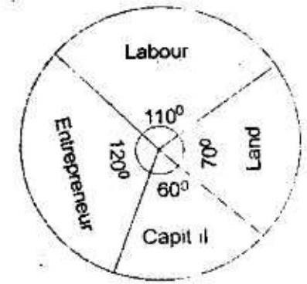

1. From the pie chart above, the percentage contribution of entrepreneur is
   1. 2.77%
   2. 33.33%
   3. 27.70%
   4. 3.33%
2. A sustained increase in per capita income accompanied by an increase in output is
   1. economies of scale
   2. economic efficiency
   3. economic development
   4. economic growth
3. The reward for capita as a factor of production is
   1. interest
   2. rent
   3. profit
   4. wage
4. The type of inflation that emanates from excess demand over supply is
   1. galloping inflation
   2. cost-push inflation
   3. demand-pull inflation
   4. imported inflation
5. Which of the following problems is associated with national income measurement?
   1. High interest rate
   2. Inflation and deflation
   3. Overpopulation
   4. population growth
6. Freedom of consumption and production are characteristics of
   1. socialism
   2. feudalism
   3. capitalism
   4. communism
7. Cost of raw materials in production is an example of
   1. marginal cost
   2. variable cost
   3. total cost
   4. fixed cost
8. Foreign exchange control in Nigeria is administered by the
   1. Money deposit banks
   2. Central Bank of Nigeria
   3. Discount houses
   4. Security and Exchange Commission

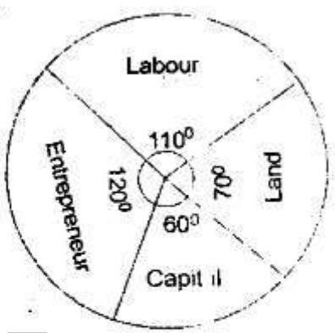

1. From the pie chart above, determine the contribution of capital if the total contribution of all factors is
   1. ₦12.50 million
   2. ₦142.50 million
   3. ₦50 million
   4. ₦7.50 million
2. The volume of output in an economy is determined by
   1. the foreign exchange rate
   2. the standard of living of citizens
   3. population density of a country
   4. efficiency in the use of factors of production
3. Given Qd = 30 - 3P, Qs = 9P – 18.

Determine the equilibrium quantity

* 1. 18
  2. 20
  3. 25
  4. 27

1. In Nigeria, industrial development can be enhanced by

2

1. ensuring stable prices for manufactured goods
2. reducing government expenditure on imported goods
3. providing efficient infrastructure
4. increasing the rate of interest
5. Capital gains tax is an example of
   1. Value Added Tax
   2. purchase tax
   3. sales tax
   4. income tax
6. Which of the following is NOT a source of government revenue?
   1. Taxes, fees, licenses and fines
   2. Interest, dividends, profits and earnings
   3. Personal income, disposable income and transfer earnings
   4. Grants, aids and borrowing
7. One of the important qualities that money must possess is
   1. heterogeneity
   2. easy availability
   3. homogeneity
   4. flexibility in value Price

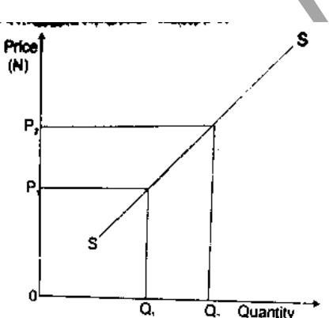

1. The graph above represents
   1. a decrease in quality supplied
   2. an increase in supply
   3. an increase in quantity supplied
   4. a decrease in supply Wages

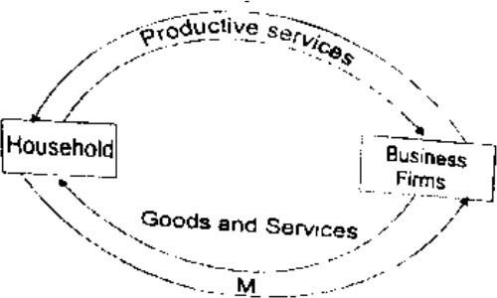

1. From the diagram above, the arrow marked M indicates
   1. payments made for foods and services
   2. payments made to factors of production
   3. the flow of capital goods
   4. the flow of economics rent
2. A change in the quantity supplied of a commodity is influenced by
   1. the price of substitutes
   2. the price of the commodity
   3. consumer's tastes
   4. technological know-how

Price Quantity

(₦) demanded

6 20

5 16

From the table above, calculate the elasticity of demand

1. 0.03
2. 0.30
3. 0.33
4. 0.04
5. One of the functions of money deposit banks in economic development is
   1. that it is banker to the government
   2. the provision of credits facilities
   3. the formulation of monetary policies

3

* 1. issuing of currency notes

1. One of the arguments against the practice of monopoly is
   1. merging of producers
   2. competition
   3. exploitation
   4. non-government ownership
2. The main reason why countries engaged in international trade is the
   1. opportunity to earn high profit in trading
   2. use of capital-intensive method of productions
   3. difference in their endowment of economic resources
   4. difference in the population structure

35.

|  |  |  |
| --- | --- | --- |
| Cup of | Total | Marginal |
| milk taken | utility | utility |
| 1 | 18 | 18 |
| 2 | 24 | 6 |
| 3 | 29 | 5 |
| 4 | X | 3 |
| 5 | 34 | Z |
| 6 | 35 | 1 |
| 7 | 35 | 0 |

From the table above, what is the value X?

1. 32
2. 35
3. 34
4. 30

36.

|  |  |  |
| --- | --- | --- |
| Quantity | Total | Marginal |
| consumed | utility | utility |
| 0 | 0 | -- |
| 1 | 10 | 10 |
| 2 | 15 | 5 |
| 3 | 17 | 2 |
| 4 | 18 | 1 |
| 5 | 18 | 0 |

From the table above, it can be inferred that there is

1. diminishing returns to scale
2. excess of demand
3. diminishing marginal utility
4. diminishing marginal productivity
   1. A well conducted census is important for
      1. economic planning
      2. providing economic opportunities in the rural areas
      3. distribution of educational materials in the cities
      4. revenue generation
   2. The cost-saving advantages which a large firm can achieve on its own is called
      1. internal economies of scale
      2. diseconomies of large scale
      3. externa diseconomies of scale
      4. external economies of scale
   3. A country uses the foreign exchange control measure to eliminate balance of payments deficit by
      1. limiting her imports to its currency value of exports
      2. limiting her exports to its currency value of imports
      3. overvaluing the country's currency
      4. reducing the nation's domestic price level
   4. The role of IBRD as an international institution is to
      1. improve trading among member nations
      2. finance private businesses in member nations
      3. facilitate the development of infrastructure in member nations
      4. D. solve the problem of balance of payments of member nations

**ANSWER KEYS:**

**1.** B

**2.** A

**3.** C

**4.** D

**5.** B

**6.** C

**7.** C

**8.** D

**9.** D

**10.** C

**11.** C

**12.** B

**13.** C

**14.** A

**15.** C

**16.** B

**17.** C

**18.** B

**19.** B

**20.** B

**21.** D

**22.** A

**23.** C

**24.**

**25.** D

**26.** C

**27.** C

**28.** C

**29.** A

**30.** B

**31.** C

**32.** B

**33.** C

**34.** C

**35.** A

**36.** C

**37.** A

**38.** A

**39.** A

# UTME 2018 ECONOMICS QUESTIONS

1. Occupational distribution of population is mainly influenced by
   1. economic factors
   2. religious factors
   3. geographical factors
   4. social factors.
2. The reward for capital is
   1. interest
   2. rent
   3. risk
   4. premium.
3. The reduction in the value of a country's currency in relation to the value of the currencies of other nations is known as
   1. deflation
   2. inflation
   3. devaluation
   4. revaluation
4. Mortgage banks give loans to investors on a long- term basis to
   1. finance agriculture
   2. establish banks
   3. acquire machinery
   4. build houses.
5. In a capitalist economy, factors of production are owned and controlled by the
   1. citizens
   2. businessmen
   3. government
   4. foreigners.
6. The establishment of industries in rural areas will help to reduce
   1. urban-rural migration
   2. rural-urban migration
   3. rural-rural migration
   4. urban-urban migration.
7. International trade is an application of the principle of
   1. industrial production
   2. mass production
   3. regional production
   4. comparative cost advantage.
8. The number of people who are qualified to work and who offer themselves for employment is called
   1. migrant labour
   2. working population
   3. labour turnover
   4. mobility of labour.
9. Which of the following is an advantage of localisation of industry?
   1. Development of subsidiary firms
   2. creation of parallel markets
   3. Development of slums
   4. Attraction of foreign capital.
10. The Economic Community of West African States (ECOWAS) has been slow in achieving its objectives because of
    1. the activities of multinationals
    2. inadequate personnel at the secretariat
    3. political instability
    4. inadequate international support.
11. Joint ventures are partnership involving
    1. the poor and the rich
    2. employers and workers
    3. government and private investors
    4. multinationals and individuals.
12. In which of the following business units are the owners mostly the customers?
    1. co-operatives
    2. limited liability companies
    3. partnership
    4. public corporations.
13. The formula index of export prices x 100, is

index of import prices

used to measure the

* 1. volume of trade between countries
  2. direction of international trade
  3. commodity terms of trade
  4. volume of imports.

## Use the table below to answer question 14.

|  |  |  |
| --- | --- | --- |
| Products | Ghana | Sierra |
| Leone |
| Coffee | 8 tonnes | 2 tonnes |
| Cocoa | 7 tonnes | 9 tonnes |

1. If specialisation should take place, then
   1. Ghana should produce coffee and cocoa
   2. Ghana would benefit by producing cocoa only
   3. Sierra Leone should not produce any of the products
   4. Sierra Leone should produce coca and Ghana coffee.
2. Which of the following is an invisible item?
   1. Petroleum services
   2. Processed rice
   3. Processed milk
   4. Banking services
3. The full meaning of OPEC is
   1. Oil and Petroleum Exporting Countries
   2. Original Petroleum Exporting Countries
   3. Organisation of Petrol Exporting Countries
   4. Organisation of Petroleum Exporting Countries.
4. The main concern of economists is to
   1. control the growth of population
   2. redistribute income between the rich and the poor
   3. satisfy all human wants
   4. allocate scarce resources to satisfy human wants.
5. Productive resources can also be called
   1. principles of production
   2. factors of production
   3. items of production
   4. labour and materials resources.
6. The study of Economics becomes necessary because of the
   1. large population size of the world
   2. scarcity of resources
   3. opportunity cost of goods and services
   4. need to satisfy every desire of man.
7. The type of demand that exists between torchlight and battery is
   1. competitive demand
   2. complementary demand
   3. composite demand
   4. independent demand.
8. The population density of a town made up of 50 square kilometre land area and 100 million people is
   1. 50,000 people per square kilometre
   2. 0.2 million people per square kilometre
   3. 0.5 million people per square kilometre
   4. 20 million people per square kilometre

## Use the table below to answer question 22 and 23.

|  |  |  |  |  |
| --- | --- | --- | --- | --- |
| X | 2 | 3 | 4 | 5 |
| F | 2 | 5 | 2 | 1 |

1. From the table, the mean of the distribution is
   1. 2.2
   2. 2.5
   3. 3.2
   4. 4.5 23.
2. What is the median of the distribution?

A. 5

B. 4

C. 3

D. 2

1. Human wants are insatiable because wants are
   1. limited while means are scarce
   2. unlimited and means are also unlimited
   3. limited and means are also limited
   4. unlimited while means are scarce.

## A country's budget allocation to various sectors of the economy is shown in the pia chart below. Use it to answer question 25 and 26

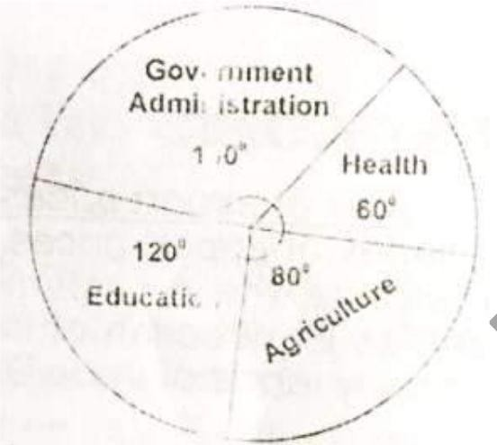

1. If the budget of the country was

$7,200.00, how much is allocated to education

* 1. $2,400.00
  2. $2,000.00
  3. $ 200.00
  4. $ 1,000.00

1. What is the ratio of expenditure on health to Agriculture?
   1. 2:3
   2. 3:4
   3. 4:3
   4. 5:4
2. Which of the following items is not an example of circulating capital?

3

* 1. Raw material
  2. Money
  3. Fuel
  4. Machinery

1. The principle of comparative cost advantage was propounded by
   1. David Ricardo
   2. Alfred Marshal
   3. J.S. Mill
   4. Adam Smith
2. The rate at which a country's exports is exchanged for her imports is
   1. trade balance
   2. balance of payments
   3. terms of trade
   4. balance of currency account.
3. Efficiency of labour in a country is determined by the following except the
   1. social attitude to work
   2. education and training
   3. total population
   4. working conditions of workers.
4. The diagram below represents a production function.

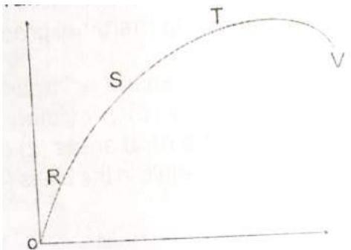

At which of the points does diminishing returns set in?

A. R

B. S

C. T

D. V

1. Taxes and government expenditures are instruments of
   1. monetary policy
   2. tax policy
   3. economic policy
   4. fiscal policy.
2. A situation in which a commodity is sold abroad below its cost of production in the home country is known as
   1. dumping
   2. counter trade
   3. bilateral trade
   4. trade liberalisation.
3. The Family Support Programme in Nigeria essentially focuses on
   1. the generation of employment
   2. the alleviation of poverty
   3. agricultural and industrial development
   4. economic emancipation of women.
4. The Economic Commission for Africa was set up by the
   1. UNO
   2. ECOWAS
   3. OAU
   4. IMF

## Use the histogram below to answer question 36 and 37.

1. If the pass mark was 40, how many students passed the examination?
   1. 100
   2. 120
   3. 160
   4. 200
2. How many students took the examination?
   1. 280
   2. 240
   3. 200
   4. 80
3. Utility is the satisfaction derived from
   1. production
   2. distribution
   3. consumption
   4. demand.
4. When a union is composed of workers with the same skill it is called
   1. an industrial union
   2. a workers' union
   3. a craft union
   4. a technical union.
5. The major objective, of a revenue allocation formula in a country is to
   1. share revenue between the public and private sectors
   2. ensure the financial viability of the country
   3. share revenue between the different tiers of government
   4. divert revenue from areas of surplus to areas of needs.

**ANSWER KEYS:**

**1.** A

**2.** A

**3.** C

**4.** D

**5.** B

**6.** B

**7.** D

**8.** B

**9.** A

**10.** C

**11.** C

**12.** A

**13.** C

**14.** D

**15.** D

**16.** D

**17.** D

**18.** B

**19.** B

**20.** B

**21.** D

**22.** B

**23.** B

**24.** D

**25.** A

**26.** B

**27.** D

**28.** A

**29.** D

**30.** C

**31.** C

**32.** B

**33.** A

**34.** D

**35.** A

**36.** A

**37.** A

**38.** C

**39.** A

**40.** C